HIRO and Pivot Approach Documentation

Contents

HIRO Physical configuration 1

# Grx Architecture

HIRO GRX is divided in two sides: Real Time Control and Non Real-Time control.

|  |  |
| --- | --- |
| RT Control | Non RT Control |
| * This side contains a RT loop called “Handler”. * Handler calls forceSensorPlugin::control() every 5 ms. * If excessive computation takes place inside of control exceeding the clock of 5ms there is a chance the QNX thread will crash. * Code should not consume more than 3ms. | * All Corba related functions take place on this side. * forceSensorPlugin.idl   + functions defined within this class are called from CORBA which are non real-time. * Simplest way to debug data inside forceSensorPlugin::control() will be through a CORBA call that copies variables in the control function. * Another alternative for debugging is through: “Data Logger” |

# HIRO Physical configuration

The home configuration of the joint angles is shown as follows:

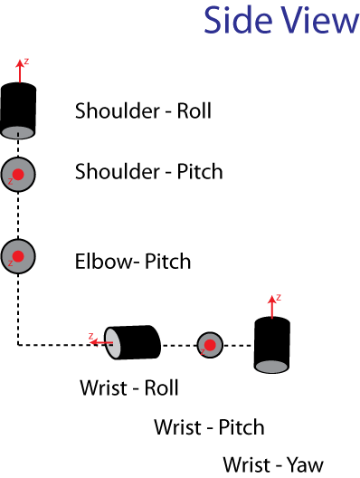

# Probabilistic Approach